A title should be the fewest possible words that accurately describe the content of the paper (left, bold, sentence case, 14pt)

Author Name¹, Author Name², Author Name³ (11 pt)
¹ Affiliation1 (9 pt)
² Affiliation 2 (9 pt)
Correspondence: author1@email.com
Article Info |  | ABSTRACT (10 PT)
Article history:  Received Jun 12th, 20xx  Revised Aug 20th, 20xx  Accepted Aug 26th, 20xx |  | A well-prepared abstract enables the reader to identify the basic content of a document quickly and accurately, to determine its relevance to their interests, and thus to decide whether to read the document in its entirety. The Abstract should be informative and completely self-explanatory, provide a clear statement of the problem, the proposed approach or solution, and point out major findings and conclusions. The Abstract should be 100 to 200 words in length. The abstract should be written in the past tense. Standard nomenclature should be used and abbreviations should be avoided. No literature should be cited. The keyword list provides the opportunity to add keywords, used by the indexing and abstracting services, in addition to those already present in the title. Judicious use of keywords may increase the ease with which interested parties can locate our article (9 pt).
Keyword:
The first keyword; the second keyword; the third keyword; The fourth keyword is five keywords. (There are a minimum of five keywords and a maximum of six keywords, align left.)

© 2025 The Authors. Published by Edukarya. This is an open access article under the CC BY license (https://creativecommons.org/licenses/by/4.0/)

INTRODUCTION (Capital, bold, Times new romance 11 pt)
The introduction contains (1) research background; (2) research objectives; and (3) research contributions (benefits); and (4) includes a review of the previous literature followed by the novelty of the research or the originality of the article; try to have references to articles from journals from the last 10 years that strengthen the justification for originality. The introduction should not be divided into sub-chapters of background, problem formulation, and objectives. The beginning of the paragraph is one time tab. Citations are written in bodynote format and are relevant to the bibliography (it is recommended to use the Mendeley application or other reference management application programs such as EndNote, Reference Manager, or Zotero) (Times New Romance 11, before after 0).

RESEARCH METHODS
The research method includes the type of research, research population, research sample/subject, and technical data analysis. You can use multilevel numbering if necessary. Don't forget to provide a title and picture number (below the picture and serial number starting from number 1), as well as the title and table number (above the table with a serial number starting from number 1). (Times New Romance 11, before after 0).

RESULTS AND DISCUSSION
The results and discussion contain the findings of the research and scientific discussion. Research findings must be supported by adequate data. This section should answer the research hypothesis, and describe the comparison with the results of previous studies. The results and discussion at least contain (1) (what/how elements) whether the data presented has been processed (not raw data), set forth in the form of tables or figures, and given easy-to-understand explanations; (2) (the why element) in this discussion section shows a link between the results obtained and the basic concepts and/or hypotheses. The discussion must be supported by real and clear facts; and (3) (what else? ), whether there is conformity or contradiction with the results of previous research. Avoid writing in the form of bullet numbering or list item models; preferably, even though it is a list item, it is still written in the form of descriptive paragraphs. Articles can be written in Indonesian or English. Articles must be written according to the template. The maximum number of pages is 20 pages with an A4 writing field size and a normal margin format (2.54 cm x 2.54 cm). Foreign words or terms use italics or italics. (Times New Romance 11, before after 0). When loading tables and figures, the numbering is a continuation of the previous number. Each table and figure must be given a title. (New Romance 11, before and after 0)

Table
The table is in the middle. Use Times New Roman and a font size of 8 to 11. Horizontal lines in the middle of the table do not need to be displayed; only the headings and the last part should be displayed, nor should there be vertical lines. Make sure you create the table correctly via the Insert Table menu. Tables should be referenced in the text by writing something like: "Tables are written with a big 'T'."

Table 1 The Title of The Table
(Capitalize Each Words and bold)
No | This line | italic
1 | This table contents, if not enough, you can reduce the font size to 8 points. Don't go any smaller than this, unless you want your readers to hurt your eyes. :-) | Regular table fill font

Try not to truncate the table on different pages, unless the size exceeds one page. If you have to truncate, don't forget to rewrite the header row for each column, given the same table serial number, and replace the title with Continuation. The table title does not end with a period. Tables do not need to use vertical lines.

Picture
As with tables, make sure each figure has a sequence number and a title. Make the images you use look like they're professionally made and don't need to be framed. Make sure to use black-and-white images.

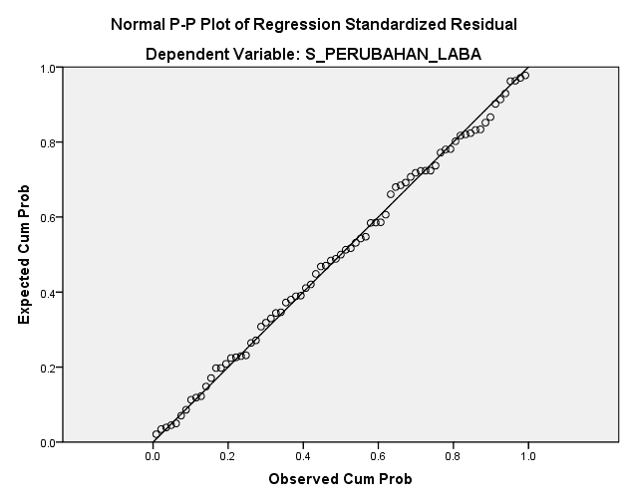
Picture 1 The Title of The Image
(Capitalize Each Words and bold)

CONCLUSION
Write down the findings or conclusions in a concise, concise, and clear manner. Conclusions are not recommended to be written into several parts or points.

REFERENCES
Written using the American Psychological Association 7th edition style, 80% of references must be primary sources, references from the last 10 years, and recommended using the Mendeley application or other reference management application program such as EndNote, Reference Manager, or Zotero. The bibliography does not need to be divided into sections. The number of references in the bibliography is at least 15. The following is an example of how to write a library :

Reference from book:
Sugiyono. (2014). Metode penelitian kuantitatif kualitatif dan R&D. Alfabeta.
Reference from scientific journals:
Artaningrum, R. G., Budiartha, I. K., & Wirakusuma, M. G. (2017). Pengaruh profitabilitas, solvabilitas, likuiditas, ukuran perusahaan dan pergantian manajemen pada audit report lag perusahaan perbankan. E-Jurnal Ekonomi Dan Bisnis Universitas Udayana, 6(3), 1079–1108.
Reference from dictionaries/encyclopedias – print :
VandenBos, G. R. (Ed.). (2007). APA dictionary of psychology. Washington, DC: American Psychological Association.
Reference from dictionaries/encyclopedias – online :
Arcus, D. (2001). Attention deficit / hyperactivity disorder (ADHD). In B. Strickland (Ed.), The Gale encyclopedia of psychology. Diakses dari http://www.gale.cengage.com/
Reference from conference papers or seminar proceedings published – print :
Edge, M. (1996). Lifetime prediction: Fact or fancy? In M. S. Koch, T. Padfield, J. S. Johnsen, & U. B. Kejser (Eds.), Proceedings of the Conference on Research Techniques in Photographic Conservation (pp. 97-100). Copenhagen, Denmark: Royal Danish Academy of Fine Arts.
Reference from conference papers or seminar proceedings published – online :
Tester, J. W. (2008). The future of geothermal energy as a major global energy supplier. In H. Gurgenci & A. R. Budd (Eds.), Proceedings of the Sir Mark Oliphant International Frontiers of Science and Technology Australian Geothermal Energy Conference, Canberra, Australia: Geoscience Australia. Diakses dari http://www.ga.gov.au/image_cache/GA11825.pdf

